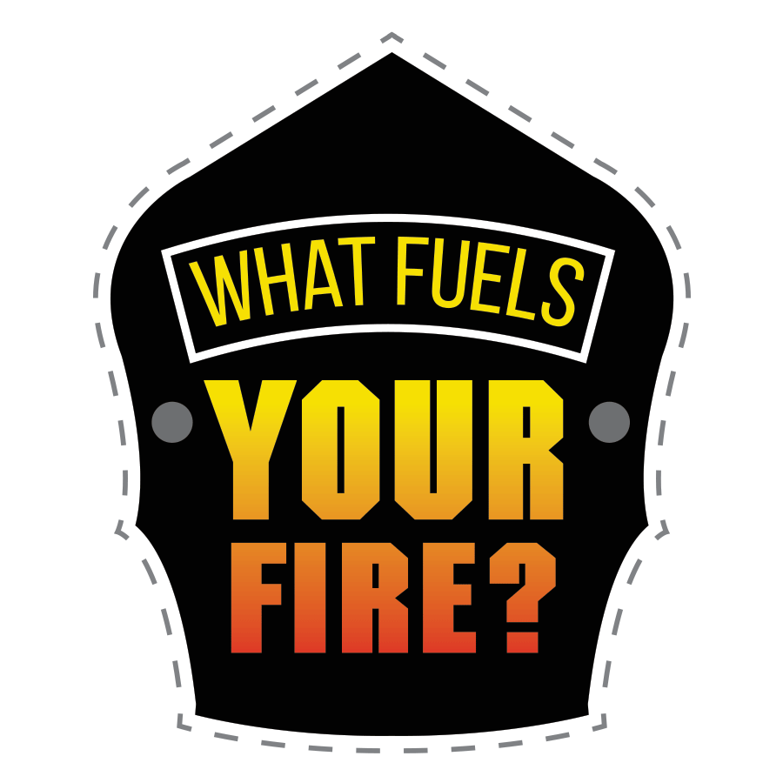
Example:
Email Wave 1

Date

Dear (name of department) personnel:

We are attempting to gain a better perspective into our department by asking you questions on your perceptions of our fire department. Your participation in this survey will benefit your department as well as your community. The data collected from this survey may be used to focus future improvements within the department and will inform your leadership as to how to best support our fire department with recruitment and retention efforts in the future.
We will be collecting information about your perspectives on a number of issues. Your responses are confidential, and we will not publish or release information from individual responses to anyone inside or outside the department. Topics will include questions about the department’s leadership, fairness, and support for diversity, as well as your own experiences with inclusion, influence, and conflict.
We expect that for most people the survey will take about 25 minutes to complete. Participation in this study is voluntary and your decision to participate will have no bearing on your relationship with the department.
If you would like to participate in the survey, please follow this link to complete the survey:
(Google Forms Link Here)
If you have any questions about this survey, please contact myself (or whoever is sending the survey) at the contact information listed below. We appreciate your assistance and look forward to learning more about you and your perceptions of culture within our fire department.
Sincerely,
Whoever is sending the survey and their contact information here

